Description:

Coordinate between input data (num_of_signals_g) to output data (data_width_g) when input > output. We save at first the incoming data (when it is valid) and start to output it in the width of out_width_g every clock cycle. In the case that the last output is smaller than that width, we add 0 to the MSB until it's fit, in order to not change the number value.

Generic table

|  |  |  |
| --- | --- | --- |
| Name | Width | Description |
| reset_polarity_g | 1 | '1' reset active high, '0' active low |
| out_width_g | 3 | Width of outputting data |
| in_width_g | 8 | Width of incoming data |

Signals table

|  |  |  |  |
| --- | --- | --- | --- |
| Name | Direction | Width | Description |
| clk | In | 1 | System clock |
| Reset | In | 1 | System reset |
| data_in | In | in_width_g | Incoming data |
| data_in_valid | In | 1 | Incoming data valid |
| data_out | In | out_width_g | Outputting data |
| data_out_valid | In | 1 | Outputting data valid |

IN BIG OUT CORDINATOR FSM

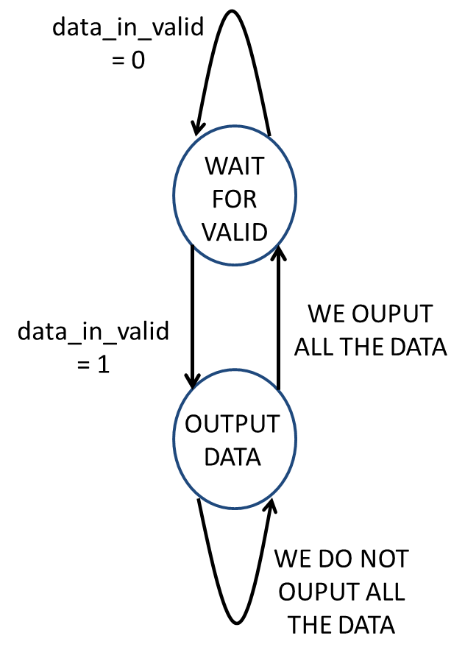

Output table

